- The JIRA fetch is implemented however, I am getting the fetching errors. Seems to be organization is blocking.
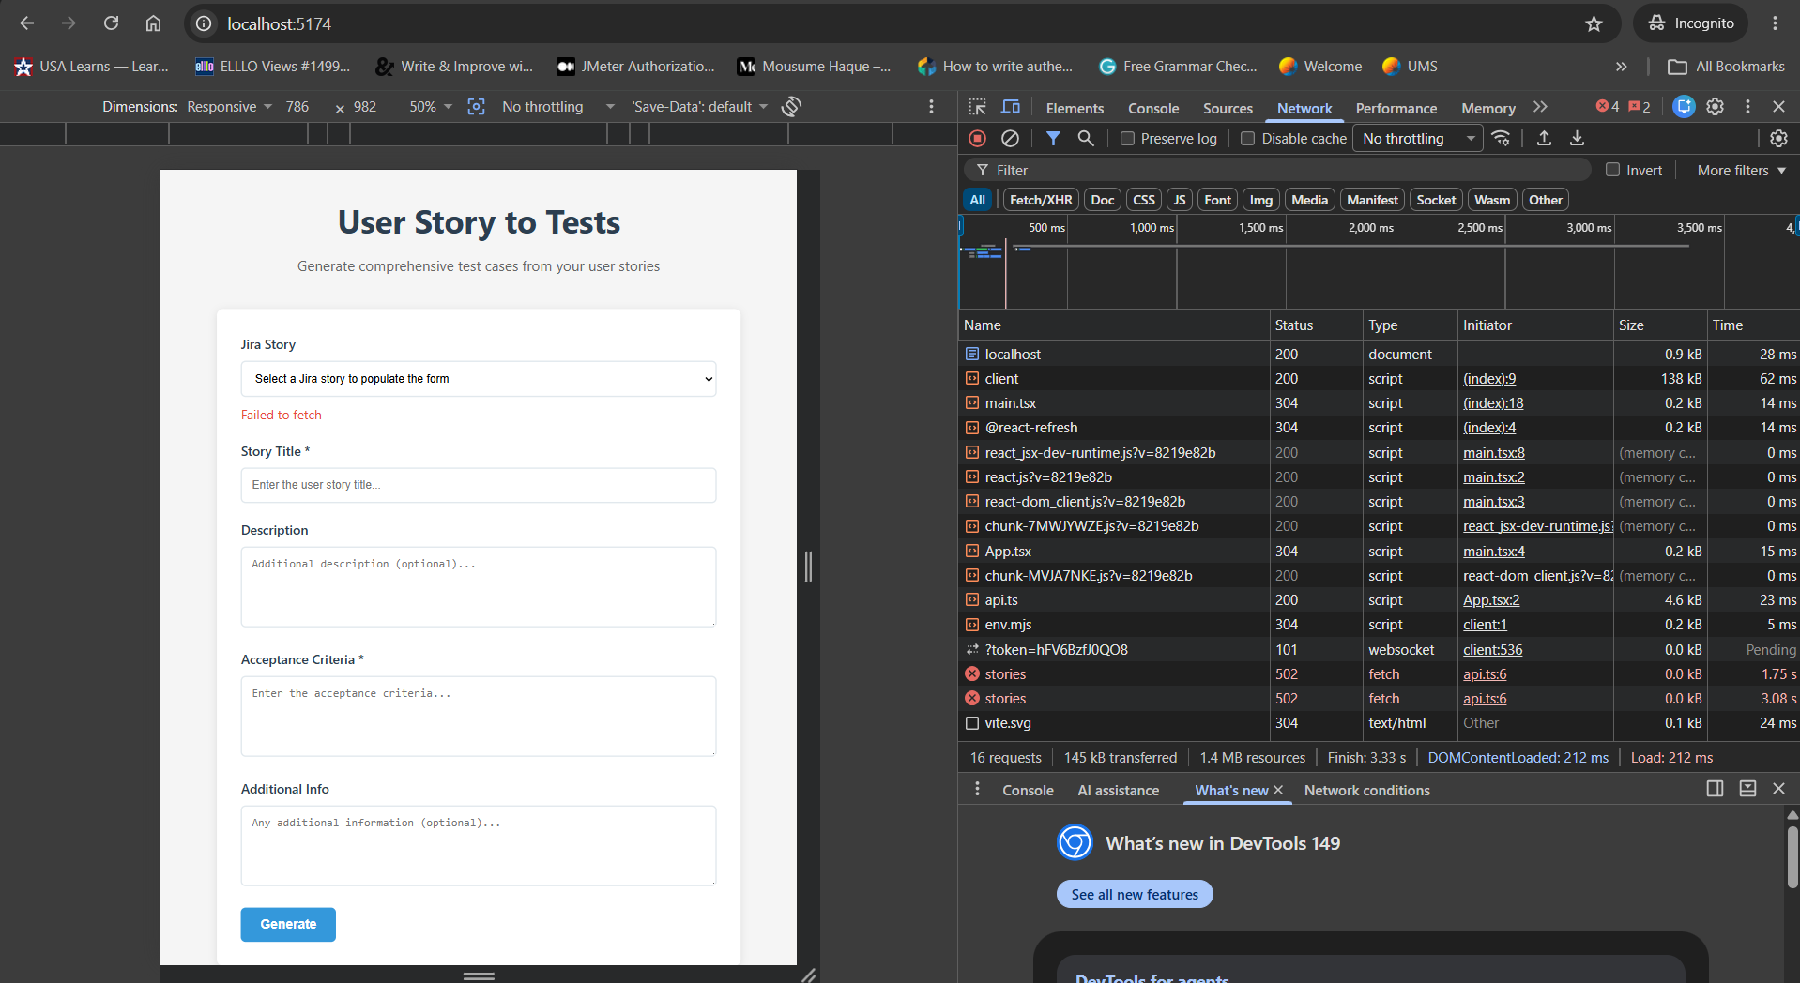
- Added the button option to feature file and test cases
